2200032991
Puru Sai Koushik

E-commerce Platform Search Function
Scenario:
You are working on the search functionality of an e-commerce platform. The search needs to be optimized for fast performance.

Product.java
package ecommerce_search;

public class Product {
int productId;
String productName;
String category;

public Product(int productId, String productName, String category) {
this.productId = productId;
this.productName = productName;
this.category = category;
}

@Override
public String toString() {
return productId + " - " + productName + " (" + category + ")";
}

}

ProductSearchDemo:
package ecommerce_search;

import java.util.Arrays;
import java.util.Comparator;

public class ProductSearchDemo {

public static Product linearSearch(Product[] products, int id) {
for (Product p : products) {
if (p.productId == id) {
return p;
}
}
return null;
}

public static Product binarySearch(Product[] products, int id) {
int left = 0, right = products.length - 1;
while (left <= right) {
int mid = (left + right) / 2;
if (products[mid].productId == id) return products[mid];
if (products[mid].productId < id) left = mid + 1;
else right = mid - 1;
}
return null;
}

public static void main(String[] args) {
Product[] products = {
new Product(105, "Laptop", "Electronics"),
new Product(101, "Shoes", "Footwear"),
new Product(102, "Shirt", "Apparel"),
new Product(103, "Phone", "Electronics")
};

System.out.println("Linear Search Result: " + linearSearch(products, 103));

Arrays.sort(products, Comparator.comparingInt(p -> p.productId));

System.out.println("Binary Search Result: " + binarySearch(products, 103));
}
}

Output:
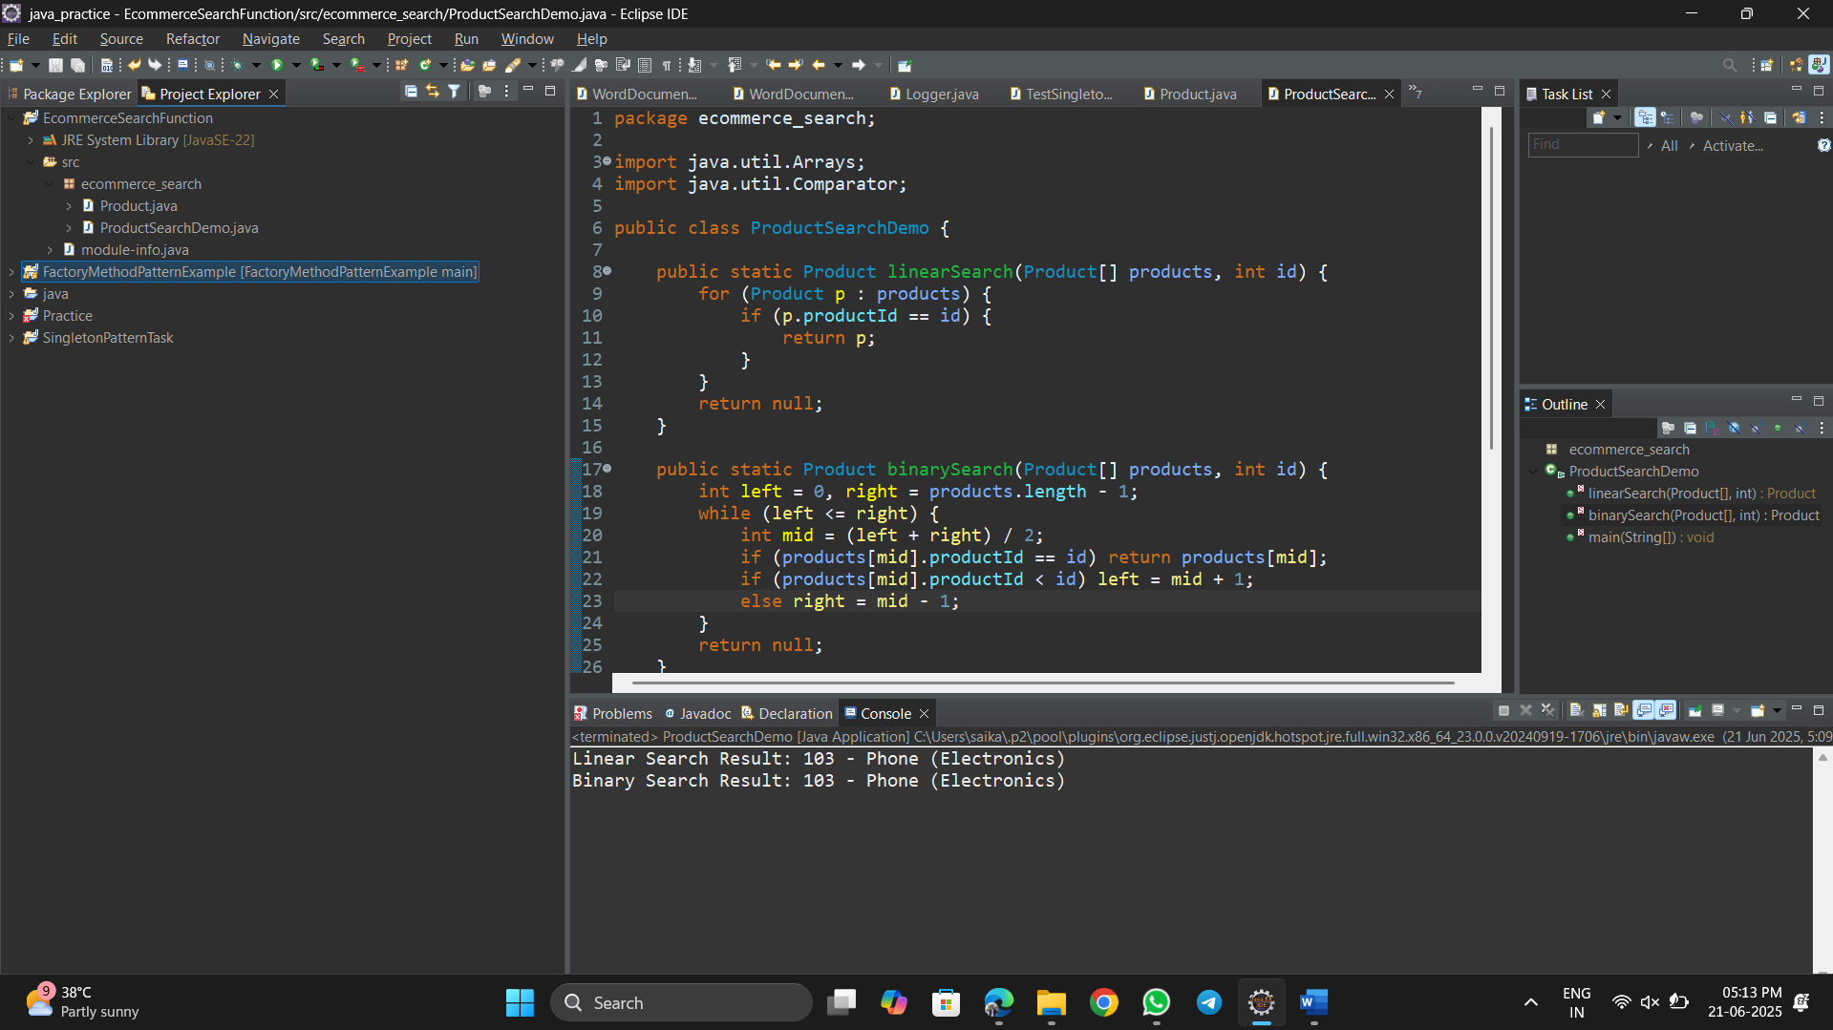



- Linear Search:
  - Time Complexity: O(n)
  - Best: O(1), Worst: O(n)
- Binary Search:
  - Time Complexity: O(log n)
  - Requires sorted array.
  - Faster for large data sets.
For e-commerce platforms with large product catalogs, binary search is more efficient when data is pre-sorted or indexed.

